Improved Copying Infrastructure for Oakland Tech

Abstract

The current system of copying for teachers at Oakland Tech is inefficient and unreliable, so it prevents teachers from getting papers to their students. This improvement is a server that monitors the printing queues of copiers and displays information about the length of queues, estimated times, whether the printer is working to teachers. This way, teachers can gauge the overall system and improve the system’s efficiency.

Background

At Oakland Tech, the current system used by teachers is multiple copy rooms around campus. Teachers print many pages, so it takes a while to finish copying. When multiple teachers make copies at the same machine, there are queues. Printers also constantly break, causing delays.

Statement of Problem

The copying/printing systems at Oakland Tech are limited because the length of copier queues are unknown, so there is not a balanced usage of copiers, making the entire system inefficient. When a copier breaks, the problem gets far worse and there is a mad scramble for the copiers and teachers have no idea when they will get their papers. An Oakland Tech teacher explained, “what's frustrating about the copy machines is that they often do not work, there's a long line in front of them, leading me sometimes to have to walk across the school and cut into planning time, just so that I can make copies for my students”. The current system is inefficient and wastes time for teachers, preventing them from focusing on teaching.

Proposed Design

*Copier Management Page with print logs*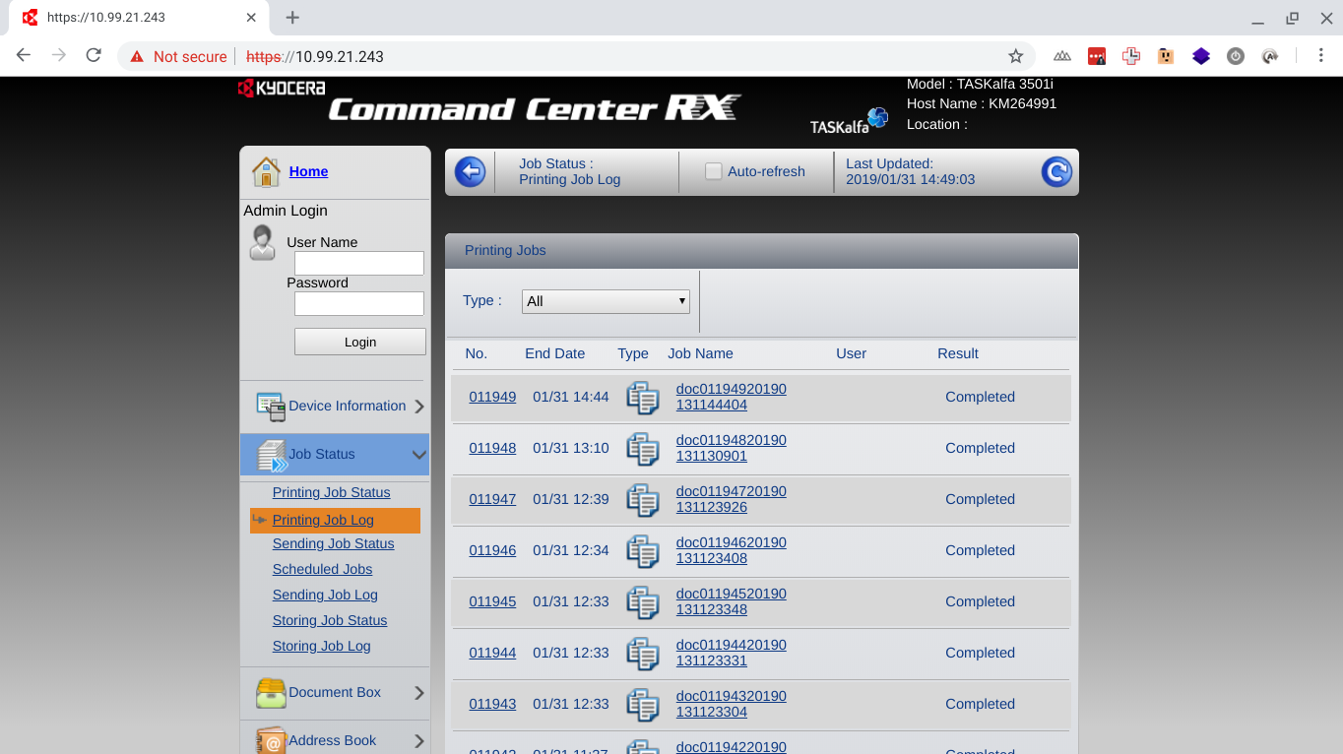

There will be a local server on the network that gets print logs from the different connected copiers from their print management page. The server will be a physical device connected to the network.

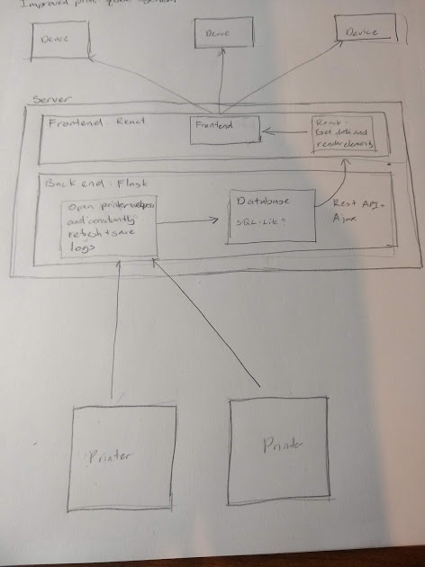

*Server Diagram*

From the print management page, the server can get all the current jobs on a copier. The server will open and get the HTML of all the copier management sites at a repeated interval. Since it is a webpage, the HTML can be easily scraped off the site. The server will scrape the start time and number of pages to print. With that information, the estimated time each job takes can be calculated. The server can also use this data to make an average of how long each copier takes to print a page making better estimations. Once the server has the information, it will store the job list in a database and calculates the job time. This information will be served from a REST (Representational State Transfer) API (Application Point Interface) via JSON (Javascript Object Notation) to the frontend. The frontend will be designed with React, a javascript framework which will render the JSON data to HTML and Javascript elements which can be accessed anywhere in the school network like any other web page.

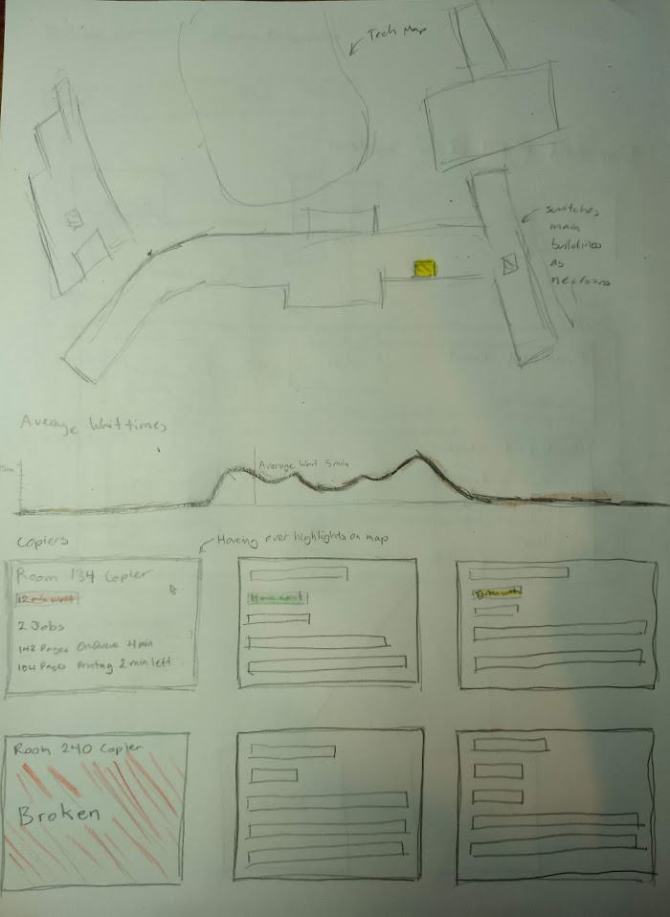

*Frontend Wireframe*

The frontend will have a map of tech. When the user hovers over the copier cards, it will highlight the room and the main building will switch floors depending on which copier room is selected. This will make it clear to the user which copier is which rather than just a room number.

There will also be a graph of average wait times. This will be calculated by the server based on previous logs and estimated wait times. This will let the user know how much time they should expect for their jobs and when to avoid printing.

Below that will be the copier cards. They’ll be sorted by the wait time. They’ll display the current wait time for each copier which will be highlighted by different colors to clearly show the wait time. They will have the job log for each copier and its progress. If a copier is reported as broken, the card will be read and easily visible, so teachers can avoid that copier and repair people can fix the copier.

Possible Benefits

The overall copying system will be vastly improved. Teachers will be able to know the current status of the entire copying system and know exactly where to make their copies and how long it will take. Teachers will be able to report copiers that are broken, quickly alerting repair people to fix the copiers and letting all the teachers not to use that copier.